STUDENT PERFORMANCE QUERIES

1. **Provide a list of all students with their grade level and study group.** (Principal wants a quick overview.)



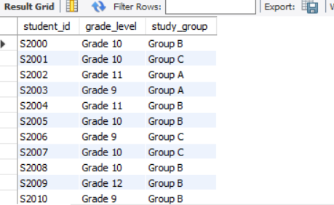

1. **Show the total number of students by gender.** (School wants to track gender balance.)



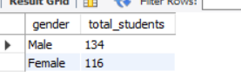

1. **Calculate the average score in each subject across the school. (**Academic board wants subject-level insights.)



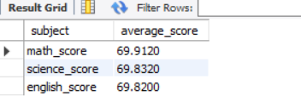

1. **Identify students who scored above 80 in Math.** (Teachers want to recognize top performers.)

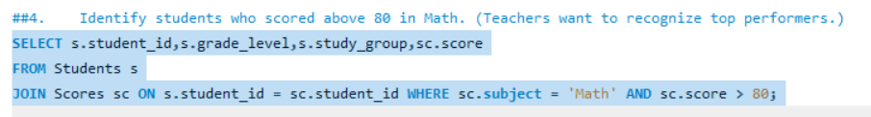

1. **How many students have an attendance rate above 90%?** (School wants to reward consistent students.)

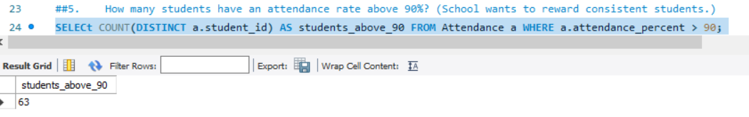

1. **What is the average attendance % per grade level**? (Helps identify classes with weak attendance.) 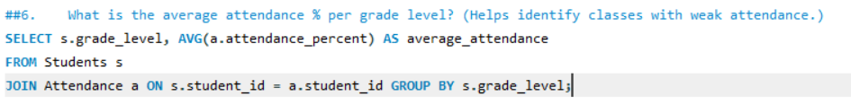

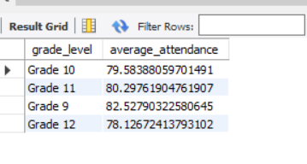

1. **Compare average Science scores by gender.** (School wants to check performance gaps.)

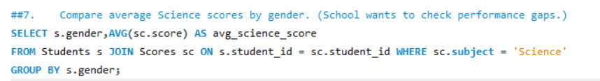

1. **List the top 5 students with the highest average scores across all subjects.** (Candidates for scholarship awards.)

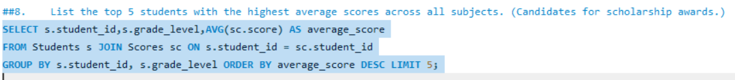

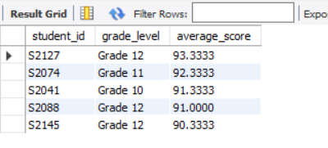

1. **Show the average score per subject by grade level**. (Teachers want to know where to improve.)

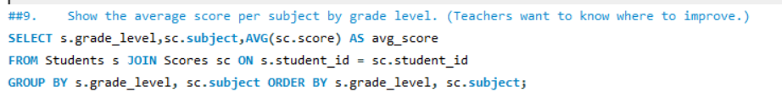

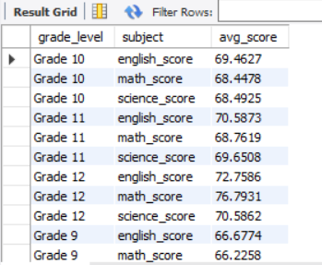

1. **Which students participate in Sports** and **have an attendance rate above 85%?** (Sports master’s request.)



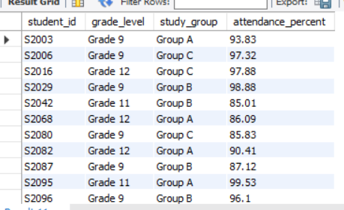

1. **Count the number of students in each extracurricular activity.** (Helps plan budget allocation.)



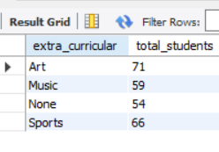

1. **Which subject has the highest overall average score?** (School wants to highlight academic strengths.)



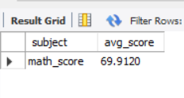

1. **Show average attendance percentage grouped by study group**. (Track study group discipline.)



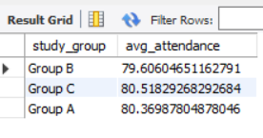

1. **List students with perfect attendance (100%).** (To be recognized on assembly ground.)



1. **What is the average Math score of students who do** not **participate in extracurricular activities?** (Check if academics-only students perform better.)

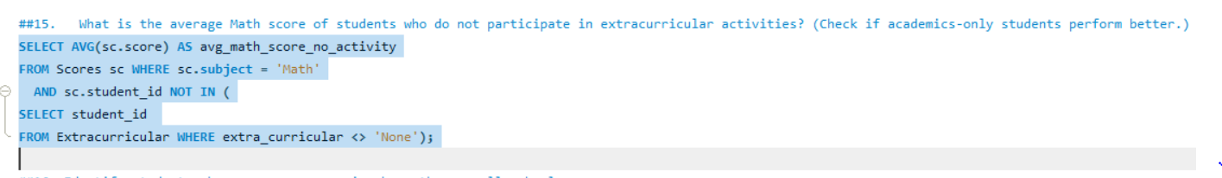

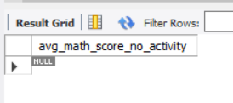

1. **Identify students whose average score is above the overall school average.** (Spot rising stars.)

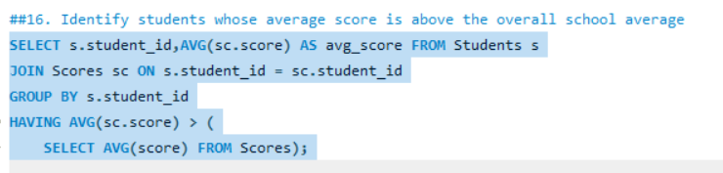

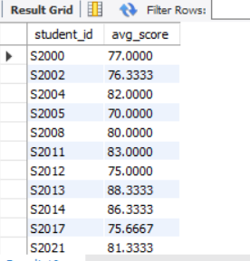

1. **Which students scored higher than the average English score of their** **grade level**? (English department review.)

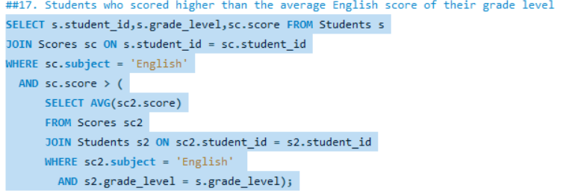

1. **Which study group has the best average attendance?** (School wants to reward the best group.)

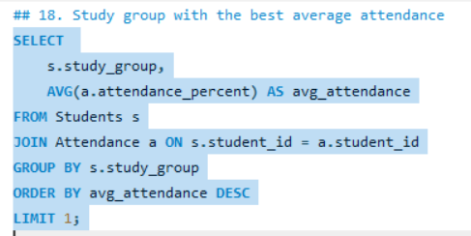

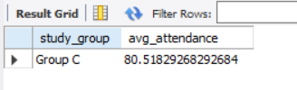

1. **Identify the student(s) with the highest average Science score.** (Nominees for Science competition.)

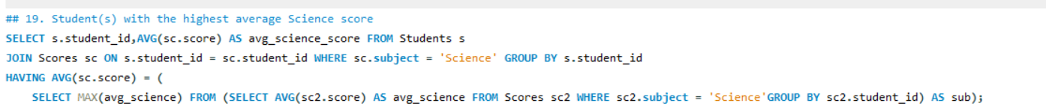

1. **Which grade level has the lowest Math average score?** (Principal wants targeted intervention.)

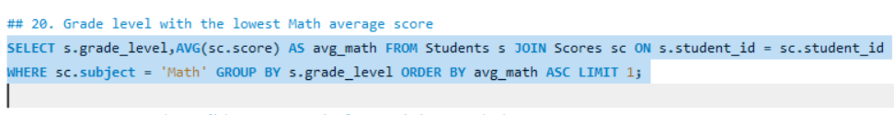

1. **Retrieve the average attendance % by extracurricular activity and rank them.** (Check which activities affect attendance positively.)

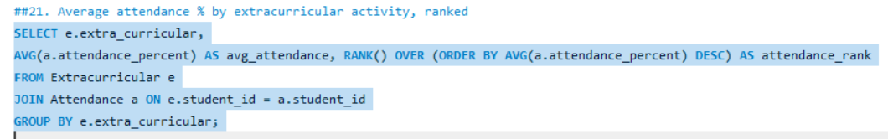

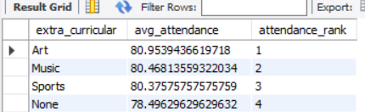

1. **Which students scored above their gender’s average in all three subjects?** (Equity-focused performance check.)
2. **Show the difference between male and female average scores per subject.** (Gender performance gap analysis.)

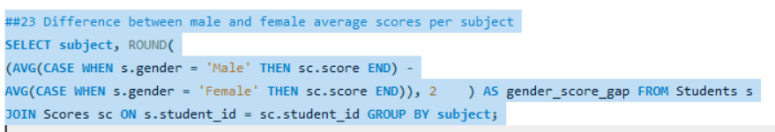

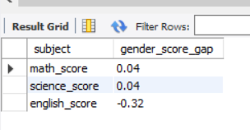

1. **Which Grade 12 students have attendance above the** **school-wide average**? (Final-year students’ discipline check.)

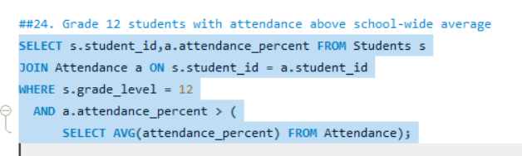

1. **Identify top performers**: **students with an average score above 85 and attendance above 90%.**

(Candidates for “Student of the Year.”)

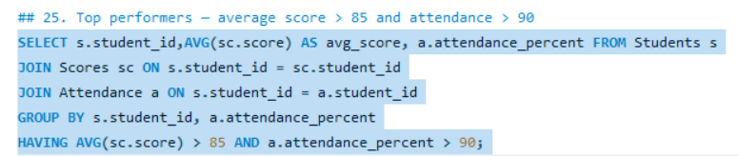

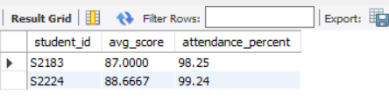

1. **Which extracurricular activity has the highest number of participants in Grade 11?** (Helps allocate activity mentors.)

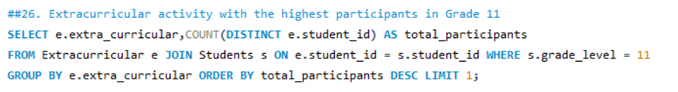

1. **List the bottom 5 students with the lowest average scores.** (For remedial class recommendation.)

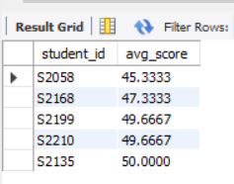

1. **Show the grade level with the best overall performance across all subjects.** (Principal wants to reward the best class.)



